 | RETRACTABLE ROOF QUESTIONNARIE
1 | Type of Roof | Steel and Glass (*950 sqft on running material) / Aluminium and Polycarbonate (*1250 /sqft on running material) / Fabric Roof (1900 /sqft on covering area)
2. | Retractable Roof /Fixed Enclosure / Pool Enclosure/Balcony Enclosure / Others
3. | Type of Movement | Telescopic Sliding / Hinged
4. | Dimension of Roof/Enclosure -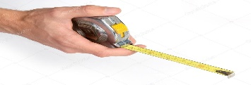 |  |  |  | Inner Dimn’s |  | Outer Dimn’s
4. |  | Length
 |  | Width
 |  | Height
5. | Type of Operation | Manual | Motorised with Remote |  |  |  |  |  | Control Switch
6. | Enclosure Opening Option | Partial Opening |  | Full Opening -  Extended Rail |  |  |  | Center  Opening |  |  | Side  Opening
7. | Polycarbonate | Clear Compact |  |  |  | Compact Embossed |  |  |  | Multiwall
8. | Colour of Polycarbonate
9. | Additional Requirement if any
10. | Site Photograph

*The per sqft cost is rough estimation and it might vary as per the site dimension, modification required in the roof.

